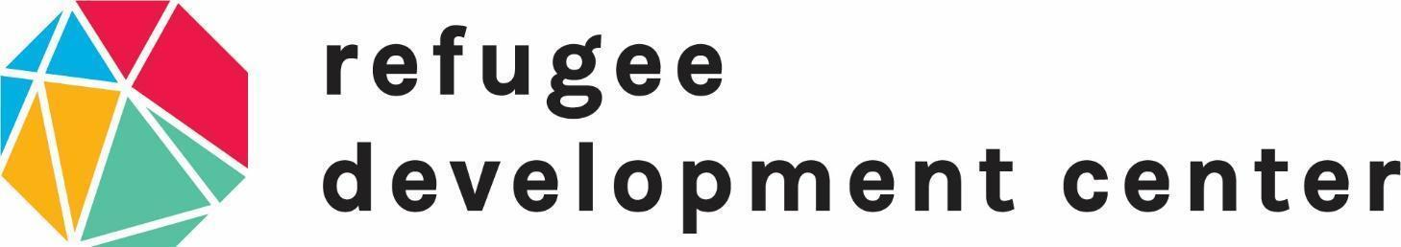

**Youth Development  
Spring 2024 Internship**

**Duration: August 26th- December 13, 2024**

The mission of the Refugee Development Center (RDC) is to cultivate a welcoming, thriving community that collaborates with refugees and newcomers through education, engagement, and support.  
Learn more at [www.refugeedevelopmentcenter.org](http://www.refugeedevelopmentcenter.org).

**Position Description:** This internship will offer a comprehensive experience in refugee post-resettlement programming at the RDC.Interns will be involved in indirect and direct service responsibilities for K-12 afterschool and mentoring programs. These services help newly arrived refugee students through activities and lessons including English, homework support, cultural immersion, sports and arts. This program takes place at a partner location in Lansing..

| **Schedule Options** | **Weekly Hrs.** |
| --- | --- |
| **Monday/Wednesday/Friday** Participate in direct service Monday and Wednesday afternoons and/or evenings.  Provide planning and administrative support Fridays. | 8 - 13 |
| **Tuesday/Thursday/Friday**  Participate in direct service Tuesday and Thursday afternoons and/or evenings.  Provide planning and administrative support Fridays. | 8 - 13 |

This is an unpaid internship. We are able to partner with academic institutions offering credit for internships. If applicable, please include any academic requirements in your application.

**Responsibilities:**

* Assist teachers of English language learning students during lessons
* Lead small groups of students in activities
* Assist in preparing curriculum and materials for classroom activities
* Recording and analyzing class data and attendance

**Qualifications:**

* English language fluency
* Access to a personal vehicle or reliable transportation 3 times per week
* Ability to work with children ages 6 to 18 from a diverse background
* Speakers of Arabic, Dari, Farsi, French, Kinyarwanda, Pashto, and Swahili are encouraged to apply

**To apply:**Email resume and cover letter to Savanna Hamed at [volunteer@rdclansing.org](mailto:volunteer@rdclansing.org). We will begin reviewing applications December 1st on a first come first serve basis. Final decisions will be made by December 8th.